Task1:
Aim: To write a Java program to check whether a given number is even or odd and
return 2 if the number is even, otherwise return 1.
Algorithm:
- Start the program
- Read an integer number
- Pass the number to a function
- Check whether the number is divisible by 2
- If it is divisible by 2, return 2
- Otherwise, return 1
- Display the returned value
- Stop the program
Program:
import java.util.Scanner;
class EvenOddReturn {
static int checkEvenOdd(int num) {
if (num % 2 == 0) {
return 2;
} else {
return 1;
}
}
public static void main(String[] args) {
Scanner sc = new Scanner(System.in);
System.out.println("Enter a number:");
int num = sc.nextInt();

int result = checkEvenOdd(num);
System.out.println(result);
sc.close();
}
}

Output:
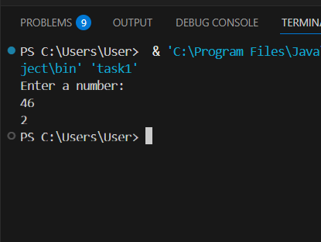

Result: Thus, to write a Java program to check whether a given number is even or odd and return 2 if the number is even, otherwise return 1.

Task 2
Aim: To Access and print the element at a given index in an array using java.
Algorithm:
- Start the program.
- Create an integer array with values: 10, 20, 30, 40, 50.
- Use a for loop starting from index 0.
- Repeat the loop until i < array.length.
- In each iteration:
  - Print the index number.
  - Print the element present at that index.
- End the loop.
- Stop the program.

Program:
public class task2{
public static void main(String[] args){
int[] array={10,20,30,40,50};
for(int i=0;i<array.length;i++){
System.out.println("Element at index " + i + ": " + array[i]);
}
}
}

Output:
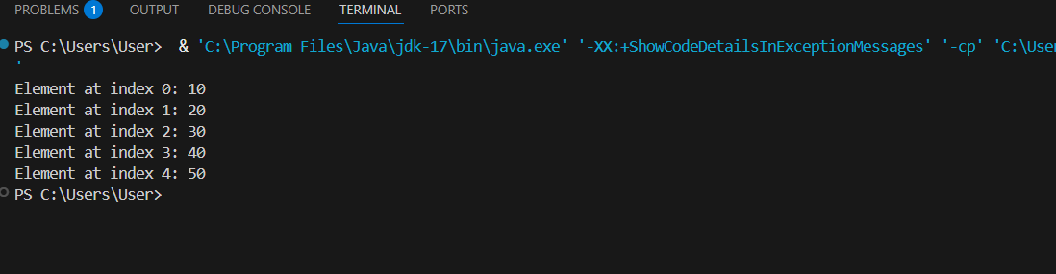

Result: Thus, the implementation of Access and print the element at a given index in an array using java was executed successfully.

Task3:
Aim: To Search for a given element in a sorted array using Binary Search.
Algorithm:
- Start the program
- Create an array with numbers 10, 20, 30, 40, and 50
- Start a loop from the first index of the array
- Check the length of the array
- Print the index number and the value at that index
- Move to the next index
- Repeat until all array elements are printed
- Stop the program
Program:
import java.util.Arrays;
public class task3{
public int binarysearch(int[] array,int target){
int left=0;
int right=array.length-1;
while(left<=right){
int mid=(left+right)/2;
if(array[mid]<target){
left=mid+1;
}
else if(array[mid]>target){
right=mid-1;
}
else{
return mid;
}
}
return -1;
}
public static void main(String[] args){
task3 obj=new task3();
int[] array={-1,0,3,5,9,12};
int target=9;
int result=obj.binarysearch(array,target);
System.out.println("element found atindex"+result+"the element is"+array[result]);
}
}

Output:
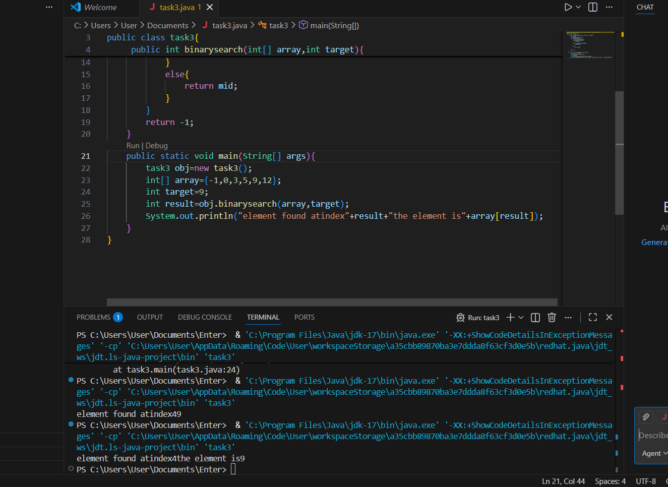

Result: Thus the implementation of Search for a given element in a sorted array using Binary Search was executed successfully.

Task4:
Aim: To Find the maximum element in an array of n integers using java.
Algorithm:
- Start the program
- Create an array with values 10, 20, 50, and 40
- Set a variable largest to 0
- Start a loop from the first element of the array
- Compare each array element with largest
- If the current element is greater, store it in largest
- Move to the next element
- Repeat until all elements are checked
- Print the largest element
- Stop the program
Program:
class task4 {
public static void main(String[] args){
int[] array={10,20,50,40};
int largest=0;
for(int i=0;i<array.length;i++)
{
if(array[i]>largest){
largest=array[i];
}
}
System.out.println("The largest element in array is:"+largest);
}
}

Output:


Result: Thus, the implementation Find the maximum element in an array of n integers using java was executed successfully.

Task5: To Given an array of integers and a positive integer K, write a program to find: The Kth smallest element using java.
Algorithm:
- Start the program
- Ask the user to enter the number of elements
- Create an array of size n
- Read n elements into the array
- Ask the user to enter the value of k
- Check if k is valid (greater than 0 and less than or equal to n)
- If k is not valid, print Invalid k value
- If k is valid:
- Sort the array in ascending order
- Find the element at position k-1
- Print the k-th smallest element
- Stop the program
Program:
class task5{
public static void main(String[] args) {
Scanner sc = new Scanner(System.in);
System.out.println("Enter the number of elements:");
int n=sc.nextInt();
int[] array=new int[n];
System.out.println("Enter the elements of an array:");
for(int i=0;i<n;i++)
{
array[i]=sc.nextInt();
}
System.out.println("Enter k value:");
int k=sc.nextInt();
if(k>n || k<=0){
System.out.println("Invalid k value");
}
else{
Arrays.sort(array);
System.out.println("the kth smallest element is "+array[k-1]);
}
sc.close();
}
}

Output:
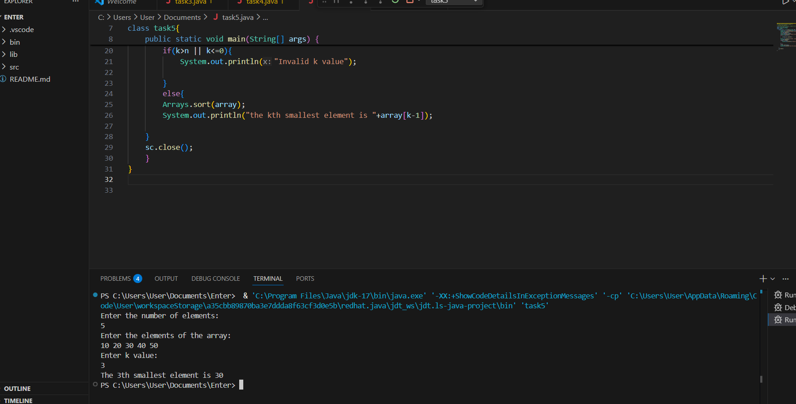

Result: Thus ,the implementation of Given an array of integers and a positive integer K, write a program to find: The Kth smallest element using java was executed successfully.

Task6:
Aim: To Print all possible pairs of elements from an array of size n using java.
Algorithm:
- Start the program
- Create an array with values 1, 2, 3, 4, and 5
- Find the size of the array and store it in n
- Start the first loop from the first element of the array
- Start the second loop from the next element after the first loop index
- Print the pair of elements (array[i], array[j])
- Move to the next pair
- Repeat until all possible pairs are printed
- Stop the program
Program:
import java.util.Arrays;
public class task6{
public static void main(String[] args){
int[] array={1,2,3,4,5};
int n=array.length;
for(int i=0;i<n;i++){
for(int j=i+1;j<n;j++){
System.out.println((array[i]+","+array[j]));
}
}
}
}

Output:
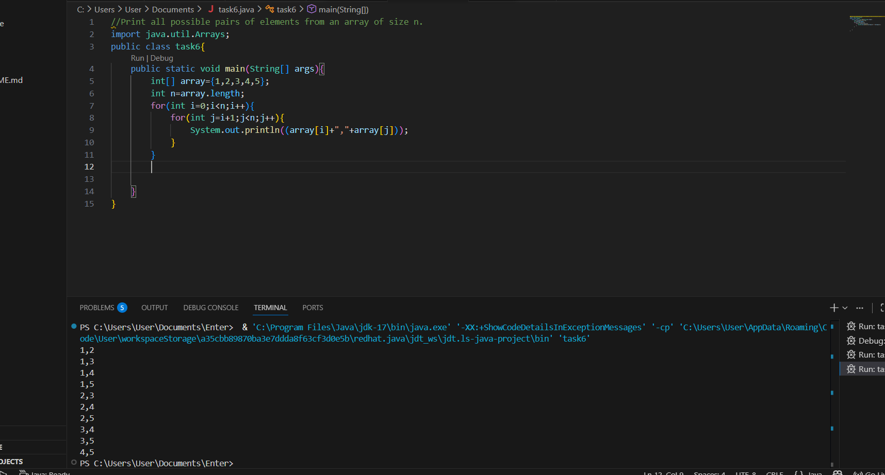

Result: Thus,the implementation Print all possible pairs of elements from an array of size n using java was executed successfully.

Task7:
Aim: To perform the program that calculates the sum of digits of a given integer, with an option to compute either the sum of even digits or the sum of odd digits based on user choice.
Algorithm:
- Start
- Input:
  - An integer num
  - An option opt (either "even" or "odd")
- Initialize: sum = 0
- Set a temporary variable temp = num
- Repeat while temp > 0:
  - Extract the last digit → digit = temp % 10
  - If opt = "even" and digit % 2 == 0 → add digit to sum
  - Else if opt = "odd" and digit % 2 != 0 → add digit to sum
  - Remove the last digit → temp = temp / 10
- After loop ends, sum contains the required digit sum
- Output: print "Sum of even/odd digits = sum"
- End
Program:
import java.util.Scanner;
public class DigitSumOption {
public static void main(String[] args) {
Scanner sc = new Scanner(System.in);
System.out.print("Enter an integer: ");
int num = sc.nextInt();
System.out.print("Enter option (even/odd): ");
String opt = sc.next().toLowerCase();
int sum = 0;
int temp = num;
while (temp > 0) {
int digit = temp % 10;
if (opt.equals("even") && digit % 2 == 0) {
sum += digit;
} else if (opt.equals("odd") && digit % 2 != 0) {
sum += digit;
}
temp /= 10;
}
System.out.println("Sum of " + opt + " digits = " + sum);
sc.close();
}
}

Output:
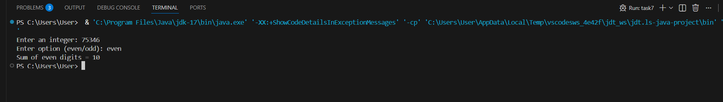

Result: Thus, the implementation calculates the sum of digits of a given integer, with an option to compute either the sum of even digits or the sum of odd digits based on user choice was executed successfully.

Task-8:
Aim: To implement the Nth Fibonacci series using java.
Algorithm:
- Start the program
- Read the value of n
- Set first number = 0 and second number = 1
- Print the first number
- If n is greater than 1, print the second number
- Repeat from 3 to n:
- Add first and second numbers to get the next number
- Print the next number
- Move second number to first
- Move next number to second
- Stop the program
Program:
import java.util.Scanner;
class task8{
public static void main(String[] args) {
Scanner sc = new Scanner(System.in);
System.out.println("Enter n value:");
int n = sc.nextInt();
int a = 0, b = 1;
if (n == 0) {
System.out.println("Nth Fibonacci number is: 0");
} else if (n == 1) {
System.out.println("Nth Fibonacci number is: 1");
} else {
int c = 0;
for (int i = 2; i <= n; i++) {
c = a + b;
a = b;
b = c;
}
System.out.println("Nth Fibonacci number is: " + c);
}
sc.close();
}
}

Output:
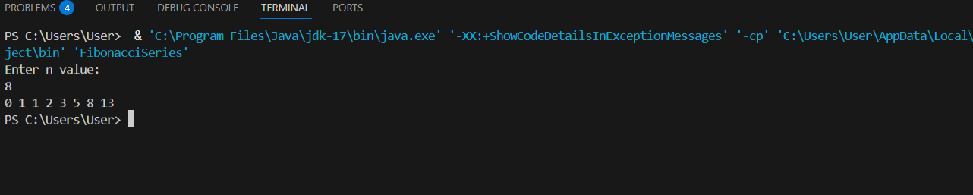

Result: Thus, the implementation Nth Fibonacci series using java was executed successfully.

Task-9:
Aim: To implement the is Palindrome Number using java.
Algorithm:
- Start
- Input: an integer n
- Store original number → original = n
- Initialize → reverse = 0
- Repeat while n > 0:
  - Extract last digit → digit = n % 10
  - Update reverse → reverse = reverse * 10 + digit
  - Remove last digit → n = n / 10
- After loop ends:
  - If original == reverse → return 2 (number is palindrome)
  - Else → return 1 (number is not palindrome)
- Output: print result
- End.

Program:
import java.util.*;
class UserMainCode
{
public int isPalinNum(int input1){
int original = input1;
int reverse = 0;
while (input1 > 0) {
int digit = input1 % 10;
reverse = reverse * 10 + digit;
input1 = input1 / 10;
}
if (original == reverse)
return 2;
else
return 1;
}
public static void main(String[] args) {
Scanner sc = new Scanner(System.in);
int n = sc.nextInt();
UserMainCode obj = new UserMainCode();
int result = obj.isPalinNum(n);
System.out.println(result);
}
}

Output:
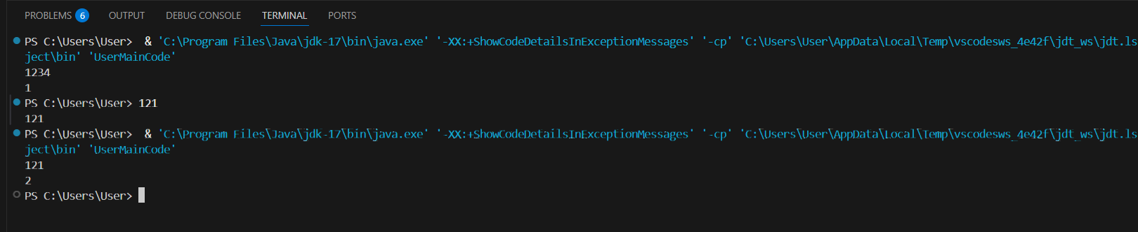

Result: Thus, the implementation is Palindrome Number using java was executed successfully.

Task-10:
Aim: To implement Sum of last digit of two given numbers using java
Algorithm:
- Start
- Read two integers input1 and input2
- If input1 is negative, convert it to positive
- If input2 is negative, convert it to positive
- Find the last digit of input1 using input1 % 10
- Find the last digit of input2 using input2 % 10
- Add both last digits
- Return the sum
- Stop
Program:
import java.util.*;
class UserMainCode
{
public int addLastDigits(int input1, int input2){
if(input1 < 0){
input1 = -input1;
}
if(input2 < 0){
input2 = -input2;
}
int lastdigit1 = input1 % 10;
int lastdigit2 = input2 % 10;
return lastdigit1 + lastdigit2;
}
public static void main(String[] args){
Scanner sc = new Scanner(System.in);
int a = sc.nextInt();
int b = sc.nextInt();
UserMainCode obj = new UserMainCode();
System.out.println(obj.addLastDigits(a, b));
}
}

Output:
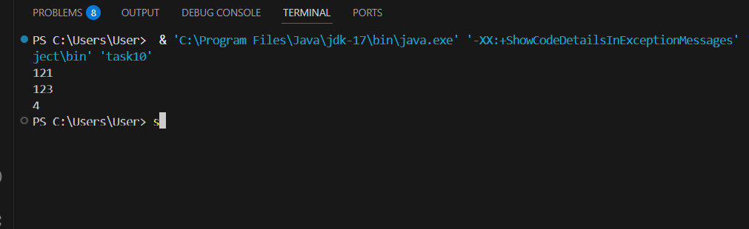

Result: Thus, the implementation Sum of last digit of two given numbers using java was executed successfully.

